WHO WE ARE
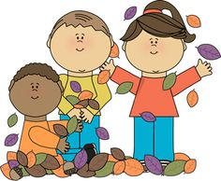

“All About Me”

Central Idea:
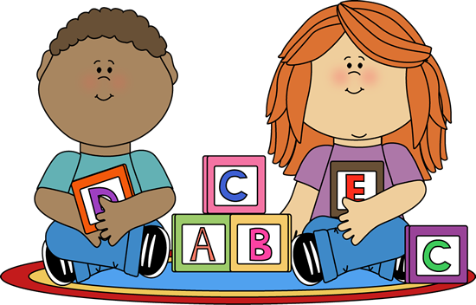
Uniqueness influences self-identity.
Lines of Inquiry:
- Physical characteristics
- Personal characteristics
- The five senses
How We Express Ourselves

“Author Illustrator Study”

Central Idea:
Perspective Influences Creativity.
Lines of Inquiry:
- Mediums used by illustrators
- Techniques used by illustrators
- Biographies of illustrators
How The World Works
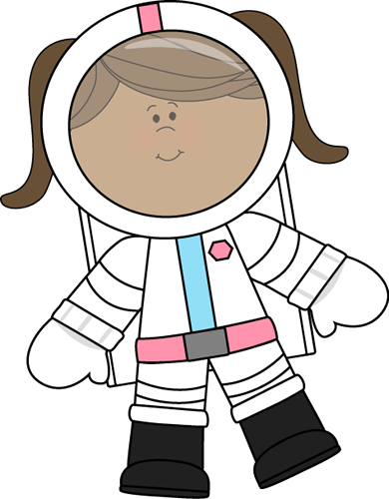
“No Place Like Space”

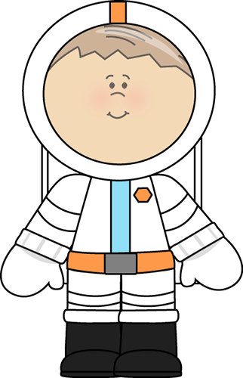
Central Idea:
Systems consist of patterns and cycles.
Lines of Inquiry:
- Cycles and position of our Earth, Moon and Sun
- Components of our solar system
- Patterns and cycles in our galaxy
Sharing The Planet
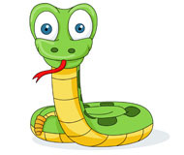
“Animals Have Class”

Central Idea
Characteristics determine animal classification.
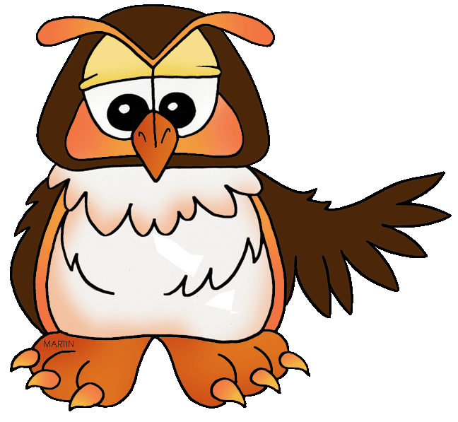
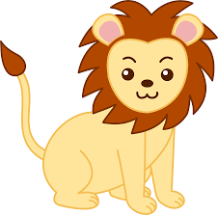
Lines of Inquiry:
- Animal Characteristics
- Animal Classification
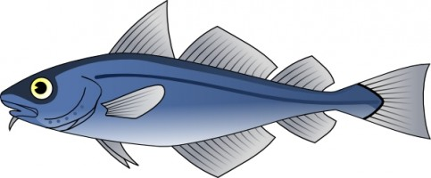
- Animal Life Cycles

How We Organize Ourselves
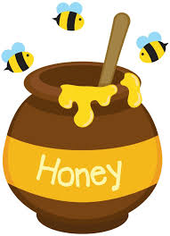
“Where Did That Come From?”

Central Idea
Products originate from sources.

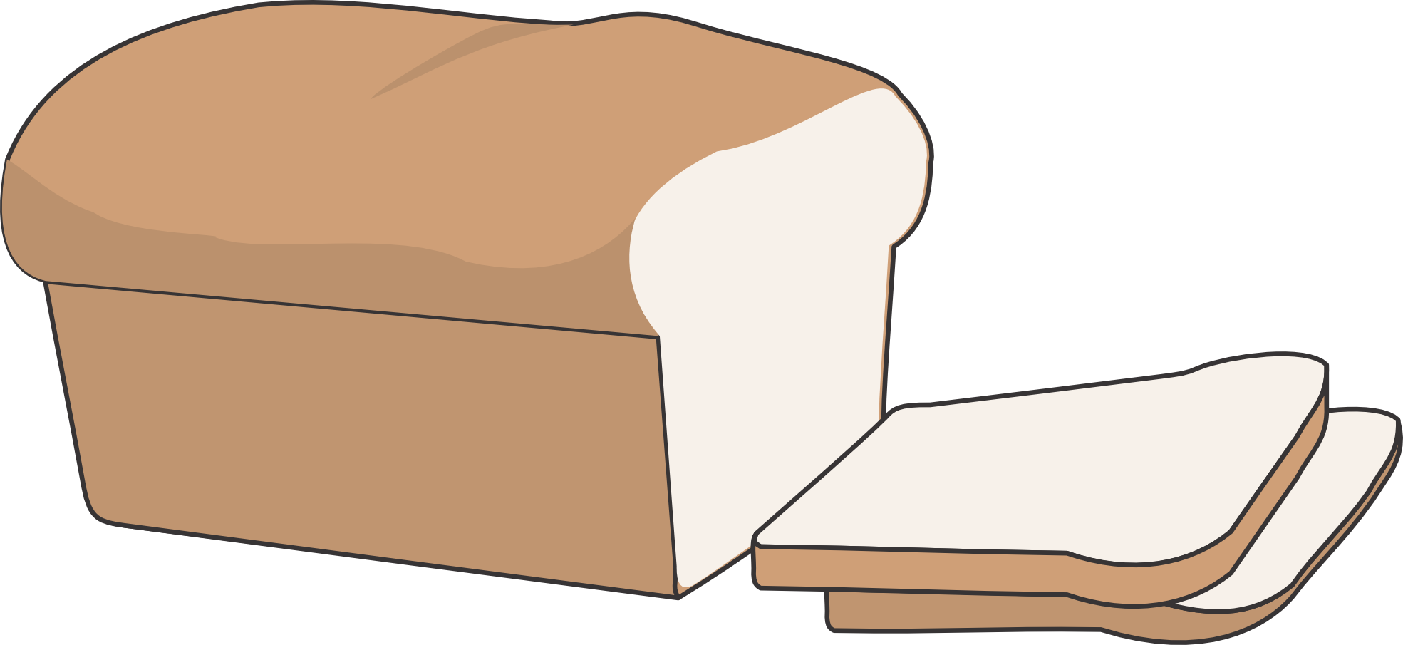
Lines of Inquiry:
- Sources of products
- How Products are Produced
- Types of Products

